CPLN 680: Advanced Topics in GIS

**Distributing Broadband in Appalachia**

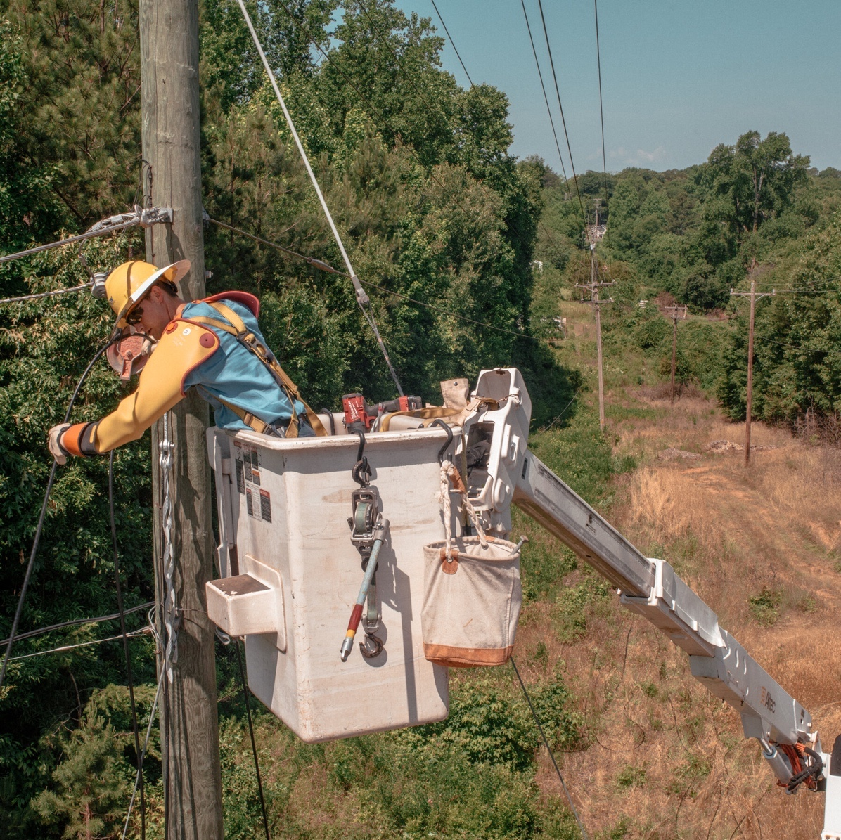[1]

Benjamin Aiken

Spring 2022

Table of Contents

**Abstract 3**

**Motivation: Appalachia in Distress 5**

**Internet: A Path to Economic Recovery? 8**

*Understanding the Digital Divide* 8

*Internet Infrastructure and Appalachia’s Options* 9

*The Computer Science Renaissance* 10

*Relief with Federal Funds* 12

**Exploratory Analysis 14**

*Current Broadband Access and Usage* 14

*Broadband Subscription Cost and Providers* 15

*Economic Trends* 17

*Age* 17

*Population Density* 20

*Education Access* 21

*Education Achievement* 22

*Industry: Mine Locations* 24

**Methods 26**

*Broadband Infrastructure Index* 26

*Broadband Subsidy Index* 27

**Results 29**

**Limitations 32**

**Conclusion 33**

**Instructions for Use of Customizable Index Workbook 34**

**Works Cited 35**

**Abstract**

As economic, education, and healthcare systems in America become more dependent on internet access, broadband, or high-speed internet, is a necessity. Some argue that internet is so essential that it has become a human right. Still, much of the nation lack any internet access (Figure 1) and far more lack reliable, high-speed internet (Figure 2).

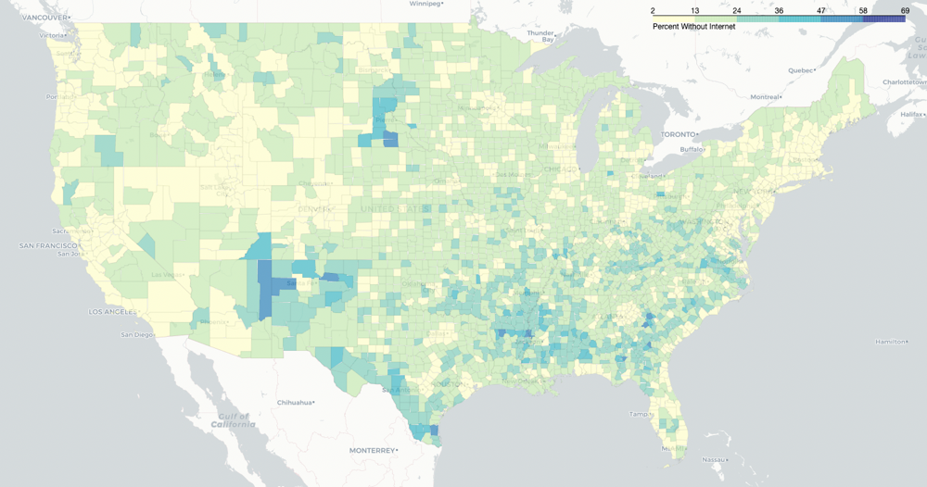

*Figure 1 – Percent without Internet*

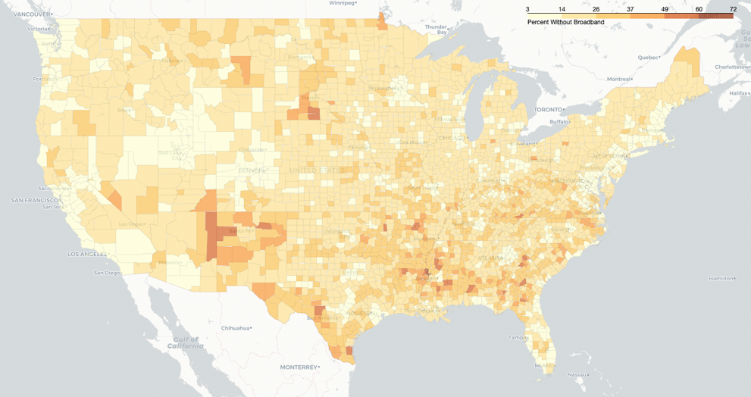

*Figure 2 – Percent without Broadband*

Rural areas, such as the Appalachian Region, are impacted the most by this ‘Digital Divide’, which is compounded further by poor economic conditions and decades of industry decline. Fortunately, the Infrastructure Investment and Jobs Act of 2021 allocates $65 billion for broadband infrastructure, much of which is specifically for rural parts of America.[2] This report investigates demographic and economic factors to determine where broadband funds are needed most in Appalachia. Two indexes are produced:

* The *Broadband Infrastructure Index* attempts to quantify each county’s need for, and the potential economic impact of, broadband infrastructure construction.
* The *Broadband Subsidy Index* attempts to quantify each county’s need for, and the potential economic impact of, broadband subscription subsidies.

The ranking of counties by these indexes provides a potential prioritization method to allocate federal funds and resources, connecting more of the United States to high-speed internet.

**Motivation: Appalachia in Distress**

Appalachia is a region of the Eastern United States defined mainly through a unified Americana culture characterized as blue collar, agrarian, and mostly rural.[3] The region traces the Appalachian Mountains from southern New York to northern Mississippi. The Appalachian Regional Commission (ARC) defines the region as 423 counties in 13 states as displayed in Figure 3.[4]

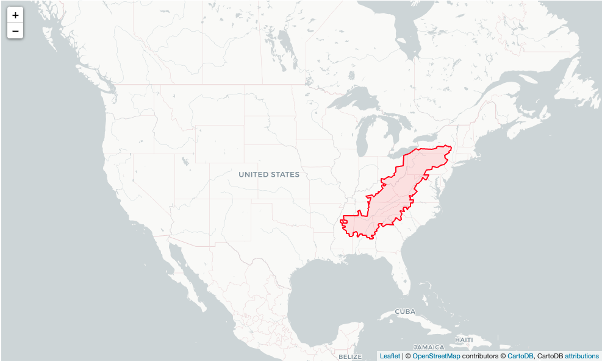

*Figure 3 – Outline of Appalachia*

The ARC divides the region further into five subregions displayed in Figure 4. These sub regions: North Appalachia in green (New York, Pennsylvania, Maryland, and northern Ohio), North Central Appalachia in purple (southern Ohio, and the majority of West Virginia), Central Appalachia in yellow (Kentucky, south West Virginia, the western part of Virginia, and northern central Tennessee), South Central Appalachia in orange (Virginia, North Carolina, and Tennessee), and Southern Appalachia in blue (Mississippi, Alabama, Georgia, and South Carolina) vary in economic stability and industry reliance.

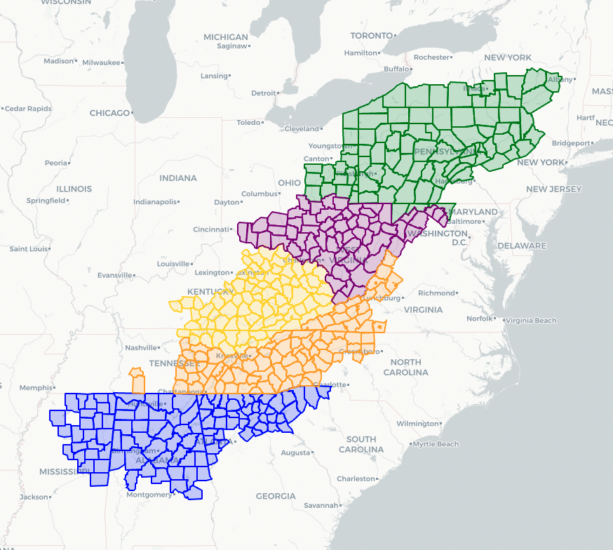

*Figure 4 – Subregions of Appalachia*

Despite the hard working and blue-collar association with the Appalachian people, much of the region has suffered economically since the mid-twentieth century. In an effort to “achieve socioeconomic parity with the nation, the federal government created the ARC in 1965 as an economic development partnership agency.4 The ARC has a budget of nearly $300 million, which it invests in business, workforce, infrastructure, and leadership development. Additionally, the commission preforms detailed research on the demographic and economic trends of the area, developing an annual Economic Index to quantify the distress status of each county.

The Economic Index is currently derived using three-year average unemployment rates, per capita market income levels, and poverty rates of every county in the US. The resulting index is compared with the rest of the United States and Appalachian counties are categorized in the following status designations:

* Distressed – counties ranked in the bottom 10% of the US (red in Figure 5)
* At-Risk – counties ranked in the bottom 11-25% (pink)
* Transitional – counties ranked in the middle 50% or 26th to 75th percentile (white)
* Competitive –top 11-25% of counties or 76th to 90th percentile (light blue)
* Attainment – top 10% of counties or 91st percentile and above (blue)

Figure 5 shows the economic status of the Appalachian counties since 2007, when the ARC developed this index.



*Figure 5 – Mine Locations and Economic Status*

Most North Appalachian counties are designated as transitional or better and have not changed significantly over the past 14 years. Southern Appalachia has a mix: some counties near Atlanta are considered competitive or attainment, but most of Mississippi is at-risk or distressed. On the other hand, almost all of Central Appalachia are at-risk or distressed and the North Central and South Central subregions are in similar situations.

While North and South Appalachia are faced with challenges of their own, the three central sub-regions are struggling economically in a large part due to the deindustrialization of the region and specifically the move away from coal fire power plants towards greener energy sources. Coal mine locations are overlayed on top of the economic status map in Figure 5 revealing clear spatial correlation between coal mines and distressed counties, which hardly change status over the 14-year period.

The mining industry is not solely responsible for the economic health of the region, but it plays a substantial role given the size of the industry. According to a study conducted by the ARC, there were 13 counties in 2005 within the central sub-regions where coal mining accounted for greater than 20% of total employment, and 9 others between 10% and 20%.[5] Even after years of decline, in 2019 the West Virginia coal mining industry employed 13,000 workers and all together supported nearly 27,000 jobs with a total employee compensation of $2.1 billion, generating $9.1 billion in economic activity.[6] According to the Bureau of Economic Analysis, West Virginia’s GDP in 2019 was roughly $72 billion, making coal mining a top industry in the state.[7] But employment is quickly declining as shown in Figure 6.

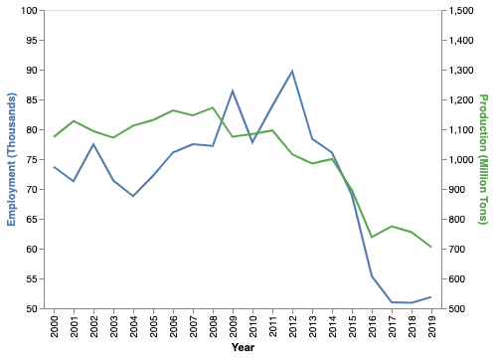

*Figure 6 – Coal Mine Employment and Production[8]*

Coal employment and production grew steadily from the 1980s to the early 2010s but has declined dramatically in the last decade. Production fell by nearly 45% in Appalachia from 2005 to 20155, driving employment down at a similar rate. In the early 2010s Kentucky coal mines employed more than 18,000 workers, but just a decade later that number is closer to 4,000.[9] Nationally, nearly 45,000 mining jobs have been eliminated in just eight years as over 300 coal-fired power plants have shut down.[10] These trends are unlikely to change course as natural gas and green energy alternatives become more prevalent, leaving central Appalachia in desperate need of a dramatic and quick economic reversal.

**Internet: A Path to Economic Recovery?**

In today’s tech reliant society, a major ingredient of economic reversal is closing the ‘Digital Divide’ that prevails throughout Appalachia. The Federal Communications Commission (FCC) approximated that there are 18 million Americans without access to broadband in the 2020 Broadband Development Report.[11] Other organizations such as Broadband Now suggests the real number is closer to 42 million – most of which live in rural communities.[12]

*Understanding the Digital Divide*

Without reliable, high-speed internet access, residents cannot “start or run a modern business, access telemedicine, take an online class, digitally transform their farm, or research a school project online.”[13] The COVID-19 pandemic exacerbated this divide leading some experts to call it the “digital chasm” since many jobs became remote in efforts to stay socially distant. Nearly a third of US households worked from home more frequently during the pandemic, a luxury predicated on a fast internet connection for most positions.[14] The internet is so essential that in a recent interview with CBS, the former CEO of Google, Eric Schmidt suggested it “is no longer optional. You can’t participate in this economy without access to the internet.”

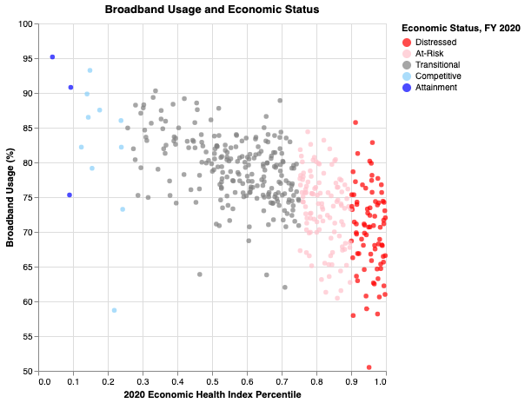

*Figure 7 – Internet Usage and Economic Status of Appalachian Counties*

Appalachian trends display the relationship between broadband and economic status plainly in Figure 7. Counties with a worse economic health percentile (as determined by the ARC’s Economic Index) and lower economic status designation have noticeably less internet usage than the counties with more stable economies.

But this issue is not exclusive to the economy and working adults. Over 55 million students were impacted by school closures and many schools resorted to online classes, requiring students to have an internet connection at home to participate.[15] Rural students are often behind their suburban and urban counterparts in academic progress, and the inability to participate in remote learning widened this achievement gap further.[16] Additionally, as hospitals crowded and access to healthcare workers was limited, telehealth became far more widespread.[17] This resource is especially impactful for the elderly in rural regions who might live a great distance from a hospital. While it is certainly not a substitute for an Emergency Room, telehealth might be the difference for some individuals that have limited access to transportation.

Without internet, a community falls behind - but once introduced, economic situations improve rapidly. To start, the development of a broadband network creates an estimated 1.2 million jobs nationally over 10 years through construction, maintenance, and indirect roles. Electronic equipment, construction, communications, metal products, transportation and distribution workers are necessary to expand the network. An investigation titled *The Impact of Broadband on the Economy* conducted by the International Telecommunication Union (ITU) traced the introduction of broadband in the United States, Germany, and several other countries in Latin America and Asia. The case studies revealed job creation in the form of telemedicine, e-commerce, online education, financial services, and service industry roles.[18] These roles combined with the telecommunications and related sectors, project an employment increase of 0.2 to 0.3% per year with each 1% increase in broadband access. [19] In 2012, broadband penetration in the US increased at a 6% growth rate from roughly 59% to 62% from 2011. This added 33,000 jobs through the creation of new business services and another 38,000 jobs because of this new economic activity, totaling in 71,000 jobs.[20]

Broadband can, undoubtably, be a major boost to a struggling economy. Additionally, many of the roles associated with the development of a broadband network and the roles produced through the internet connection do not require higher education. This distinction is important considering the context of Appalachia and the demographics of former coal miners who similarly worked well paying jobs that were accessible without an advanced degree. Considering this potential impact, the construction of a broadband network seems imperative for Appalachia.

*Internet Infrastructure and Appalachia’s Options*

According to the FCC, broadband is considered any type of internet that is “high speed” or reaches 25 Mbps download and 3 Mbps upload speeds, compared with dial up services which are far slower. Broadband comes in different forms, including Digital Subscriber Line (DSL), cable modem, fiber, wireless, and satellite, each requiring different infrastructure:

* DSL utilizes existing telephone lines but requires high quality copper lines that many rural regions lack.
* Cable modem services utilize the picture and sound coaxial lines for cable TV but again, rural regions often lack this existing system.
* Fiber optic technology exceeds DSL and modem internet speeds, but relies on another, entirely separate, set of cables that are dedicated to internet and are never pre-existing like DSL and modem services can be. Additionally, fiber optic internet speed uses light electrical signals that diminish in speed over long distances making this service reasonable for urban areas, but less effective in rural regions.
* Wireless or WiFi converts a wired internet connection into a wireless signal, but only works in short ranges and could not cover large distances in rural regions.
* Finally, Satellite broadband delivers an internet connection via a satellite rather than a cable. This is often the only option for rural residents, but it can be slower, subscriptions can be more expensive, and it requires a costly dish and a clear line of sight to the satellite itself. Mountainous regions like much of Appalachia are not always able to establish a clear line of sight resulting in unreliable connections.[21]

Without the established infrastructure, many rural residents are currently left with satellite as the only option for an internet connection at home. Ideally cable, DSL, and fiber optic networks would provide the region with far more reliable and high-speed internet, enabling these communities to close the ‘digital divide. Unfortunately, providers of these services not incentivized to build expensive infrastructure to connect just a few potential customers in remote areas. Unfortunately, the mountains that make the region unique and ideal for coal mining, also make it tremendously challenging and expensive to build the necessary broadband infrastructure; therefore, the residents that are connected are charged far more for internet than urban or suburban areas. According to the broadband access data from Broadbandnow.com, monthly subscriptions in rural Appalachia can cost as much as $200 a month, which is often beyond the budget of rural residents.[22] Ultimately, the responsibility of funding the necessary physical infrastructure for non-satellite-based broadband may fall on the government to realistically connect these areas quickly.

*The Computer Science Renaissance*

With the future of the coal industry in jeopardy, some politicians have suggested that the region could revive the economy through tech. The tech industry has historically been localized to specific regions of the country such as Silicon Valley; however, with the rise of the internet, the industry has globalized, reaching across the county and overseas. In his book *Dignity in the Digital Age: Making Tech Work for All of Us*, Congressman Ro Khanna argues that the tech revolution that has brought tremendous wealth to Silicon Valley, the district he represents, should be replicated throughout the nation. He explains that with the right tools, education, and opportunity, the Appalachian region could become a “Silicon Holler” and drastically improve economically.[23]

Appalachia would not be the first region to attempt the industry switch as other regions of America sought out the “tech revolution” to spur economic growth. The Hudson Valley started a “Tech Valley” marketing campaign in the late 1990s to attract tech companies and compete with Silicon Valley and Boston. The region includes 19 counties of eastern New York state, stretching from Franklin and Clinton counties in the north to Orange County in the south, just north of New York City.[24] The tech giant IBM is headquartered in Westchester County where several chip manufacturing plants ran for decades before downsizing in the 1990s[25] and again the 2010s.[26] Tech Valley is also home to Rensselaer Polytechnic Institute and the State University of New York (SUNY) Polytechnic Institute, which have contributed to the region’s tech growth. Research at these schools led to tech advancements including nanometer transistor computer chips, developed at SUNY Polytechnic.[27] The potential work force of these schools reportedly boosted Tech Valley’s successful bid for the $4.2 billion GlobalFoundries chip plant in 2009 and again in 2021 when the company relocated their headquarters from Silicon Valley to Saratoga County.[28]

Although Appalachia does not share Tech Valley’s academic tech focus, success in other former manufacturing areas of the nation indicate that attracting tech companies might be reasonable based on work force demographics. For example, IBM pledged $20 billion in January 2022 to open a processor factory near Columbus, Ohio.[29] Additionally, in 2021 the company made similar pledges to build two facilities in Chandler, Arizona.[30] Although these factories might not pay the Silicon Valley programmer salaries, they employ blue collar workers, which Appalachia is known for.

Several Appalachia-based organizations have attempted to bridge the tech gap and bring computer related jobs to the region with mixed results. Mined Minds, a nonprofit dedicated to teaching coding and computer science skills, was welcomed to West Virginia by Senator Joe Manchin and heralded as the savior of coal mining families. But an investigation by the New York Times revealed that the organization failed to deliver on these high expectations, potentially defrauding participants of their training program.[31] Their shortcomings are credited to disorganization, limited resources, and a lack of job opportunities despite the organization’s promises that the program would attract tech firms.

Politicians have garnered criticism for proposing the economic crisis in Appalachia can be solved with simple workforce retraining. Critics suggest the answer is not as simple as teaching coal miners to program.[32] In his article in The Atlantic titled *The False Promises of Worker Retraining*, Jeffrey Selingo claims, “Despite decades of investments by the federal government in a patchwork of job-retraining efforts, most have been found to be ineffective according to numerous studies over the years and it remains unclear to experts whether the programs are even up to the task of preparing workers for the new economy.”[33]

Still, some organizations have found limited success in tech such as Bitsource,[34] [35] which was started by former coal miners in Kentucky, and the aptly named Silicon Holler,[36] which serves as a start-up incubator in North Carolina. As impressive as these organization are, they are small and appear to be the exception rather than the rule considering the competitive landscape in tech.

Ultimately, a tech renaissance that brings chip plants and coding jobs might be possible in Appalachia, but, even if computer science is not a perfect replacement for coal mining, broadband internet is necessary for basic economic recovery.

*Relief with Federal Funds*

Appalachian relief and ARC funding has been hotly contested by the federal government for several decades. For example, the Trump administration’s initial budget proposal would have eliminated all federal funding and closed the ARC entirely, although funding was eventually provided in the final budget.[37] The Infrastructure Investment and Jobs Act (IIJA) signed into law in November 2021 allocates $65 billion towards broadband infrastructure and $1 billion for the ARC for the next five years (Figure 8). In fact, West Virginia Senator Joe Manchin’s initial opposition to the bill was a major influence in the inclusion of so much ARC support.

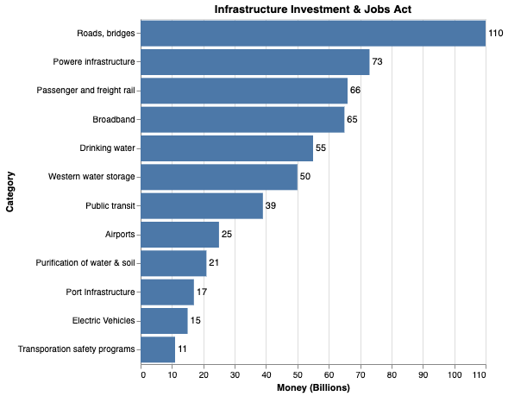

*Figure 8 – Infrastructure Investment & Jobs Act Fund Allocations*

The broadband funds are distributed in five different categories depicted in Figure 9. The majority, $42.5 billion will be distributed on the state and local level for infrastructure construction. Another $2 billion will be distributed via grants and loans by the US Department of Agriculture’s ReConnect Program for broadband infrastructure in rural areas of mostly farmland. $1 billion will be dedicated to “middle-mile networks” which connects internet access points, providing access for those in the “middle.” Additionally, $600 million will be issued as private activity bonds via state government for rural households.[38]

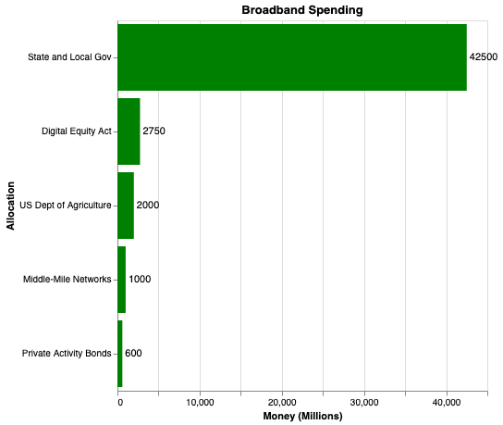

*Figure 9 – IIJA Broadband Allocations*

The final $2.75 billion of broadband spending in the IIJA is for the Digital Equity Act, which is largely designed to ensure disadvantaged communities have access to affordable internet. This act allocates money for “Digital Equity Plan” development by states and territories, State Digital Equity Capacity Grant Programs to follow through on those plans, and Digital Equity Competitive Grant Programs to promote digital inclusion and increase adoption of broadband in disadvantaged communities.[39]

The Digital Equity Act shares some similarities to the Regan administration’s Lifeline program within the FCC, which sought to ensure all Americans had access to dialing 911 in case of emergency. The federal funds are distributed as subsidies to disadvantaged communities, mainly in rural regions, where telephone service is limited and expensive. Over the last several years, the FCC has broadened the standards for these subsidies to include broadband. Some activists have argued that the Lifeline program subsidies must be expanded to truly close the digital divide and the Digital Equity Act makes progress towards that goal.[40]

Unfortunately, the IIJA is unlikely to entirely close the “digital chasm” in America. Even the monumental progress that the bill will make will take a tremendous amount of time. So, how should the funds be distributed and what parts of Appalachia should be prioritized to address the highest need and have the largest potential economic change?

**Exploratory Analysis**

To understand the Appalachian region and each of its subregions, internet access and usage, population density, working age, education access and achievement, and industry trends were investigated. Data was wrangled from a variety of sources and mapped in python using jupyter notebooks along with the altair and folium python packages. The 2020 5-year American Community Survey provides an in-depth look into the internet usage, computer access, education achievement, income level, and age makeup on the county level. Data from Broadband Now tracks the broadband access, type, and expense at the zip code level. Additionally, mine locations were wrangled from SkyTruth.org[41] in connection with the Pericak et al research study conducted on surface coal mine yearly extent.[42] Higher education locations and enrollment data was downloaded from the Integrated Postsecondary Education Data Systems (IPEDS) Data Center.[43] Finally, economic information was collected from the ARC website from 2006 to 2020.[44] All data and notebooks can be found in the GitHub repository [here](https://github.com/CPLN-680-Spring-2022/Aiken_Ben_AppalachiaBroadband).

*Current Broadband Access and Usage*

For the purposes of this investigation, broadband access is defined as the existence of terrestrial broadband infrastructure, meaning a household *could* subscribe to a high-speed internet service other than satellite at home via a broadband provider, regardless of price. This access metric is exclusive to terrestrial broadband, which includes cable, DSL, fiber optic or wireless, but does not include satellite. Usage, on the other hand is defined as *connecting and using* internet at home, measured by the 2020 5-year American Community Survey. The difference here is key – many Americans in Appalachia live in places where broadband exists, but not all residents subscribe likely due to high prices.

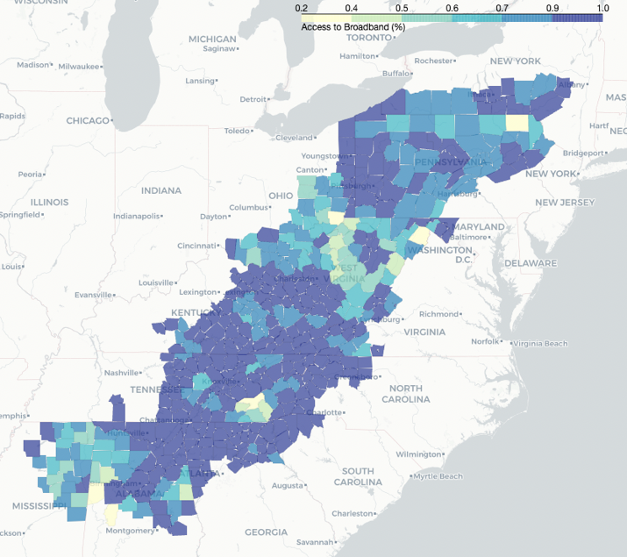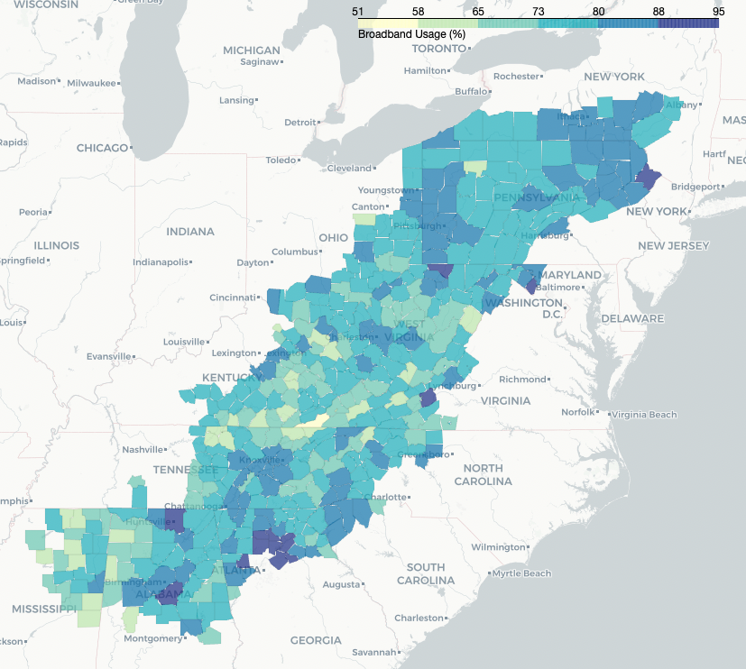

*Figure 10 – Broadband Access (Left) and Usage (Right) in Appalachia*

Figure 10 reveals that much of Kentucky has internet access (map on the left) but residents of these same counties report limited usage (map on the right). This contrasts with parts of West Virginia, where there appears to be low access and low usage in many counties. The relationship between access and usage is display below in Figure 11.

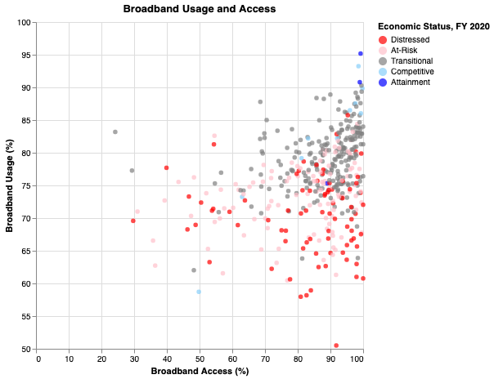

*Figure 11 – Broadband Usage vs Access*

Most Appalachian counties report that more than 80% of residents have access, but less than 80% of residents use internet at home. While it is entirely possible that not all residents want internet, this relationship is likely related to the expense of a subscription.

*Broadband Subscription Cost and Providers*

As discussed in the motivation section, the landscape of Appalachia makes broadband options limited and expensive, leaving many residents with satellite as the only option. Figure 12 displays the average lowest cost of broadband subscriptions, with the mean near $50 a month. This value is derived from survey information on the zip code level, which is used to calculate a county average weighted by population of each zip code. While most subscriptions are between $30 and $70, some county’s lowest subscription exceed $100. This is of course the cheapest option, which might limit download and upload speeds and require additional equipment costs. Considering nearly 21% of households in Appalachia earn less than $20k annually and are struggling with poverty, these prices are likely a major deterrent.

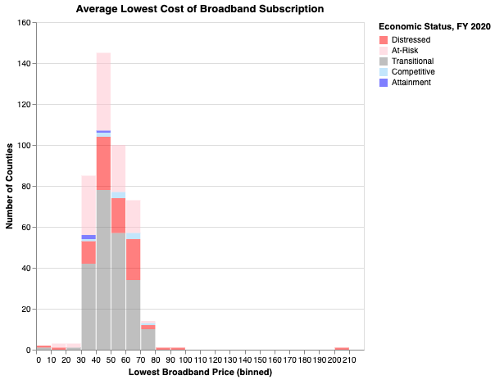

*Figure 12 – Average Cost of Least Expensive Broadband Subscription*

In some counties there are very few broadband providers, which may lead to higher prices. This is explored further in Figure 13. The plot on the left compares usage and the number of providers, which do not appear to have clear correlation. On the other hand, the plot on the left shows the lowest price and the number of providers with the $200 outlier removed. These features have a slight negative correlation suggesting that in some cases, more providers have driven broadband costs down.

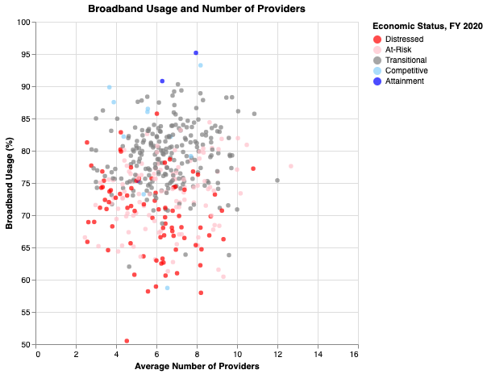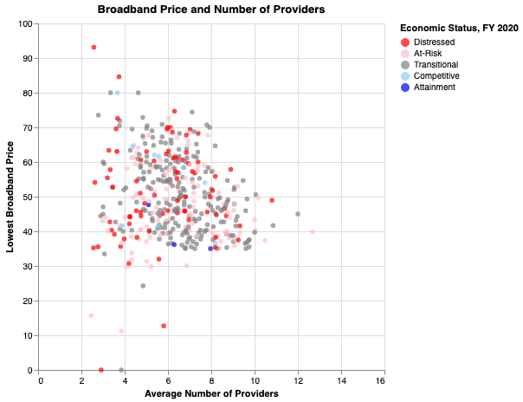

*Figure 13 – Broadband Usage and Provider Count (left) and*

*Price vs Provider Count (right)*

*Economic Trends*

As discussed earlier, much of Appalachia is struggling economically and consistently fall in the bottom tenth of counties in the United States using the ARC’s Economic Index. Figure 5 shows the change over time in gif version, which reveals that some counties have rebounded, some have declined, and others are stagnant in the distressed or at-risk designations. Figure 14 displays the average economic index percentile for five years (2015-2020) further identifying the counties with consistent struggles. The distressed counties are largely in Kentucky and West Virginia, while at-risk counties are present in ten of the thirteen states, mainly in Tennessee, North Carolina, Alabama, and Mississippi.

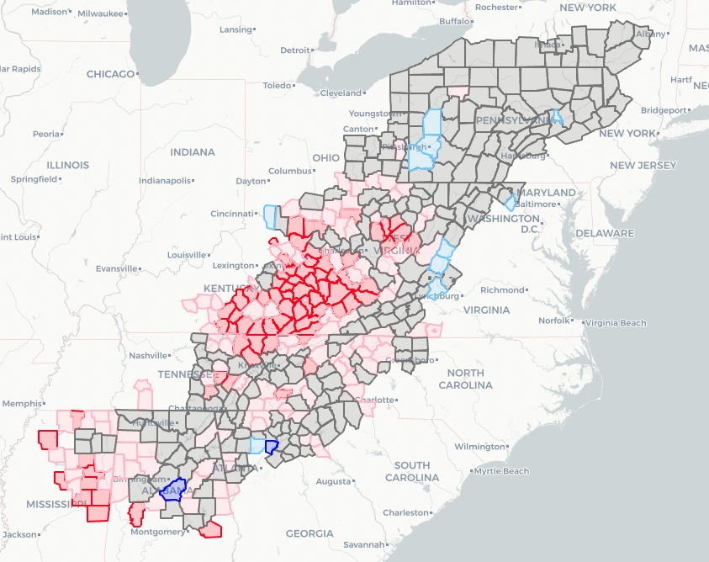

*Figure 14 – 5-Year Average Economic Status (2015-2020)*

On the other hand, Northern Appalachian states are generally stable compared with the rest of the region. With one exception in Pennsylvania, all of New York, Pennsylvania, and Maryland are either transitional or competitive. Northern Ohio is also largely transitional, but Southern Ohio is almost entirely at-risk. The Georgia counties near Atlanta are consistently strong, as are most of Virginia’s counties.

*Age*

Broadband access impacts all age groups. It enables children to participate in remote learning and research school projects, adults to work remotely and participate in the online economy, and seniors to receive medical attention via telehealth. While these are all positive outcomes, the best target to rebound the Appalachian economy would be working age adults (18 to 64), since this group is the main driver of the economy. Figure 15 shows the percentage of working age residents in each county.

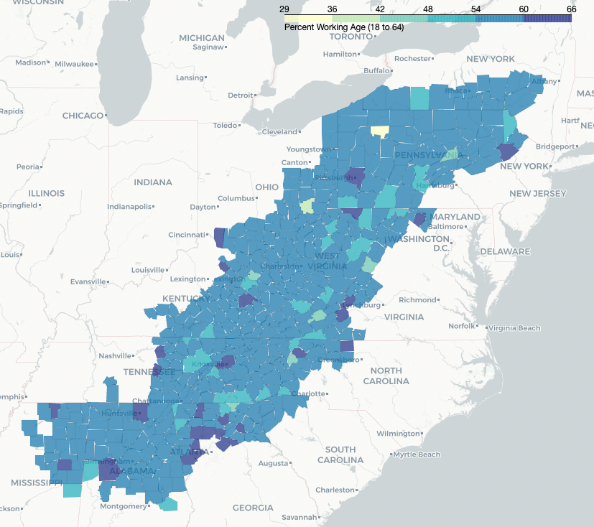

*Figure 15 – Traditional Working Age Population Percentage*

Traditionally, working age is considered 18 to 64 since most Americans start working full-time (or become a student) at 18 and retire around 64. However, if the introduction of broadband is meant to open new job opportunities, perhaps a better metric would be a younger working age, 16 to 44. Broadband infrastructure will take time to construct, and many states allow teenagers to start work before they turn 18, so 16 might be a more appropriate lower bound. According to a study completed by the AARP, roughly 78% of workers change careers at some point and the average age of that change is just 31 years old.[45] Although broadband and related job opportunities are not exclusive to former coal miners, it is important to note that Zippa.com lists the average age of coal miners at 42.1 years old.[46] Considering career changes and coal miner ages, 44 should be an appropriate upper bound for a revised working age mapped in Figure 16.

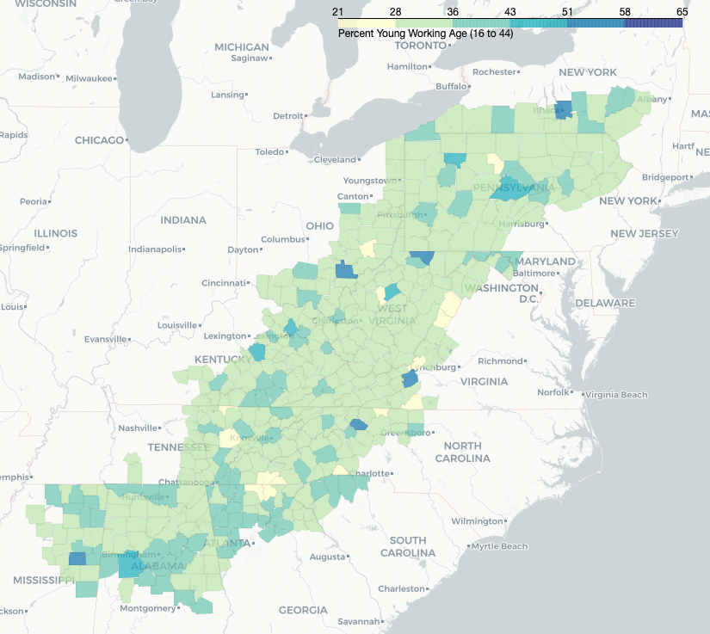

*Figure 16 – Revised Working Age (16-44) Population Percentage*

Traditional working age and revised working age produce strikingly different maps shown in Figures 15 and 16. There are several counties that have a significantly younger population that might be impacted to a greater degree by broadband connectivity. Finally, the relationship between both working age groups and internet usage is displayed in Figure 17.

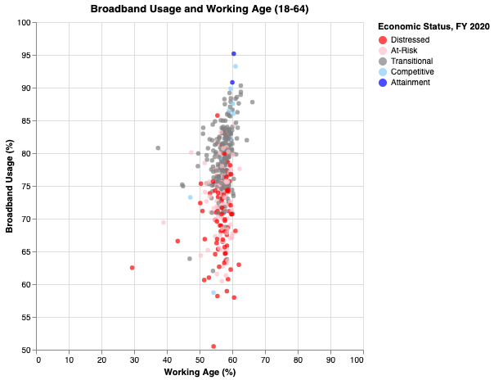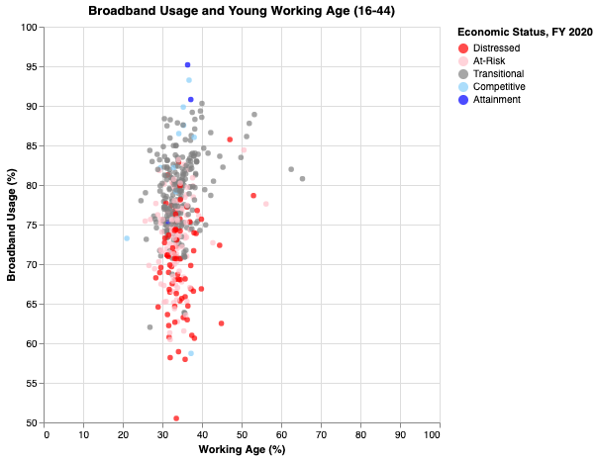

*Figure 17 – Working Age and Internet Usage*

Most counties hover around 60% traditional working age, yet they vary in terms of young working age percentage – from 20 to 65%, but neither have a clear correlation with broadband usage.

*Population Density*

Population density, by definition, is highest in urban areas where there tends to be consistent broadband coverage and lowest in rural regions with the least broadband coverage. Figure 18 reveals which counties are the most rural – mainly in West Virginia, Kentucky, and Mississippi. Pennsylvania, Tennessee, North and South Carolina, and Georgia are generally denser with a few exceptions.

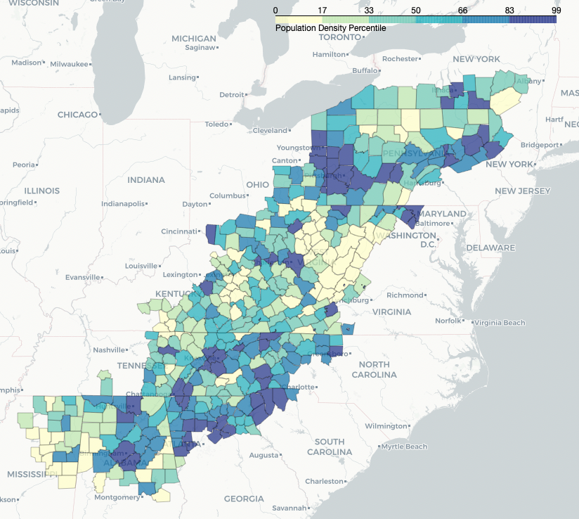

*Figure 18 – Population Density*

The relationship between density and broadband is plainly displayed in Figure 19, which clearly shows a positive correlation between access and density. The scatter plot also reveals a strong relationship between economic status and density with most distressed counties falling in the bottom half of the population density percentile. Conversely, the competitive and attainment counties are clustered towards the top where density and broadband coverage is greatest.

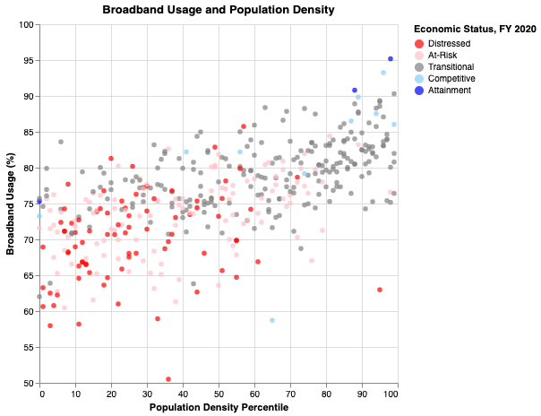

*Figure 19 – Broadband Usage and Population Density*

*Education Access*

Higher education institutions such as community colleges, technical schools, and 4-year colleges and universities serve as anchor institutions for communities and play a unique role when discussing broadband. Most of these schools have broadband on campus, which can be free for the public. While this does not replace at-home broadband it can still serve as a resource for residents who cannot connect at home or cannot afford a subscription. Figure 20 plots all higher education institutions in Appalachia with a 50 mile buffer.

While the institution locations are relevant, enrollment varies a great deal. For example, Penn State, located in Centre County, Pennsylvania has nearly 100,000 students, but other counties have 2-year community colleges with enrollment below 1,000 students, less than 1% of Penn State. Rather than the count of schools per county, enrollment is likely a better measure of education access. Figure 20 colors the counties by enrollment per population showing some counties have as much as 12% of the population enrolled in higher education, mainly counties with large public state schools. Still, enrollment has limitations as a measure of access since not all schools are open and affordable for everyone since tuition and acceptance rates vary a great deal.

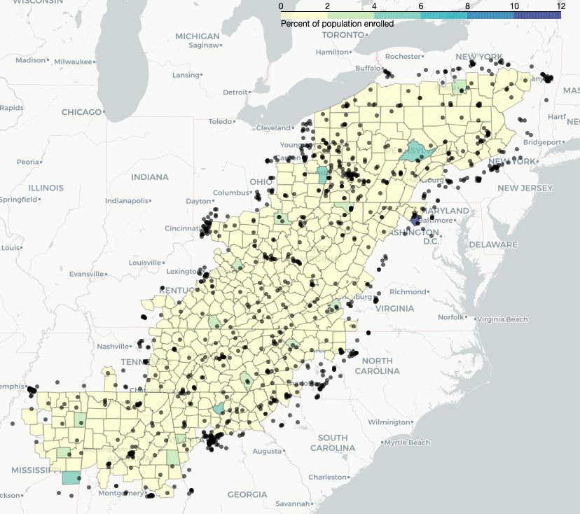

*Figure 20 – Higher Education Enrollment per Capita*

One could argue that workers are best poised to shift careers with access to a higher education institution for training. This may be true, but with broadband, residents can attend school remotely or enroll in online courses, making proximity to a physical campus not entirely necessary. Additionally, if tech is the desired sector, in-person education is even less necessary since the work is so grounded to the computer and internet. This is not to suggest that in-person learning is obsolete, rather to explain that remote parts of Appalachia should not be excluded for this alone. If anything, these remote regions need broadband more desperately since they have less access to a physical school.

*Education Achievement*

Separate from education access, education achievement is crucial when considering broadband access. Individuals who have a college degree or even just a high school diploma, have far more job opportunities and a much lower unemployment rate than those who do not.[47] With that in mind, targeting counties with lower high school graduation rates may connect individuals with less education to jobs residents desperately need. The coal industry does not require advanced degrees, so coal mining counties likely have fewer college graduates and therefore more residents with limited job options as the coal mines close. Fortunately, many of the infrastructure construction roles associated with broadband do not require advanced degrees and other jobs created by internet connection would not either.

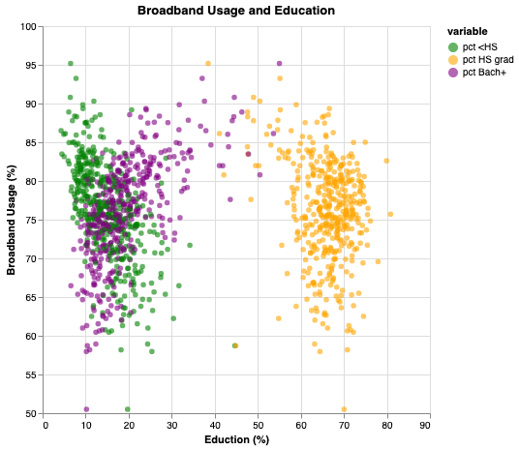

*Figure 21 – Broadband Usage and Education Level*

As shown in Figure 21, counties with a higher percentage of the population with at least a bachelor’s degree (purple) are more likely to have a higher broadband usage rate. Conversely, counties with a higher percentage of the population with less than a high school diploma (green) or at least a high school diploma (orange) trend in the opposite direction. Ultimately, this suggests that areas with higher educational achievement have greater access to broadband. These three education achievement levels are mapped in Figures 22 and 23.

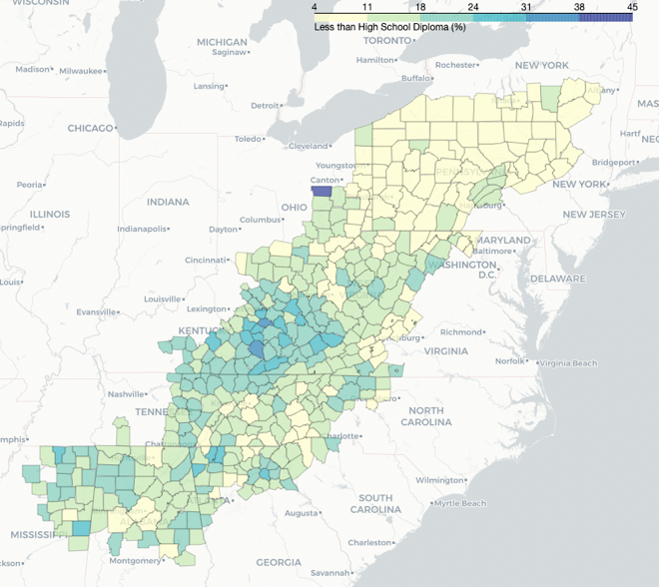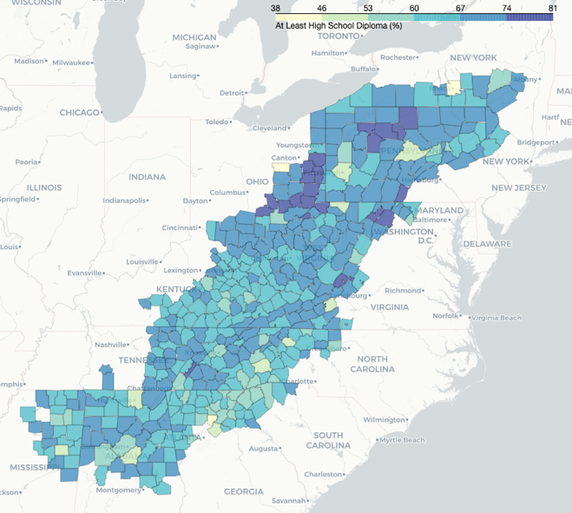

*Figure 22 – Education Achievement in Appalachia: Less than High School (left),*

*At Least High School or Equivalent (right)*

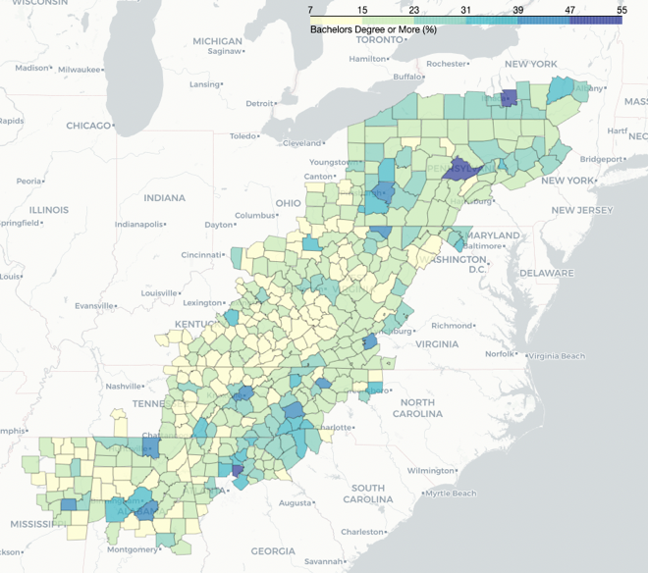

*Figure 23 – Education Achievement in Appalachia: At Least Bachelors*

Education achievement levels appear to cluster in Figures 22 and 23. Counties with a large percentage of the population without a high school diploma (or equivalent) are concentrated heavily in Kentucky. Conversely, Pennsylvania counties have high rates of high school and college educated residents, with very low percentages of the populations without a high school diploma. Parts of Pennsylvania, North and South Carolina, and Georgia show high overall education rates.

*Industry: Mine Locations*

The economies of many central Appalachian counties have been tied with the coal industry. Zooming in specifically to the 238 counties in the North Central, Central, and South Central subregions, the 2020 coal mines are displayed as a heat map in Figure 24.

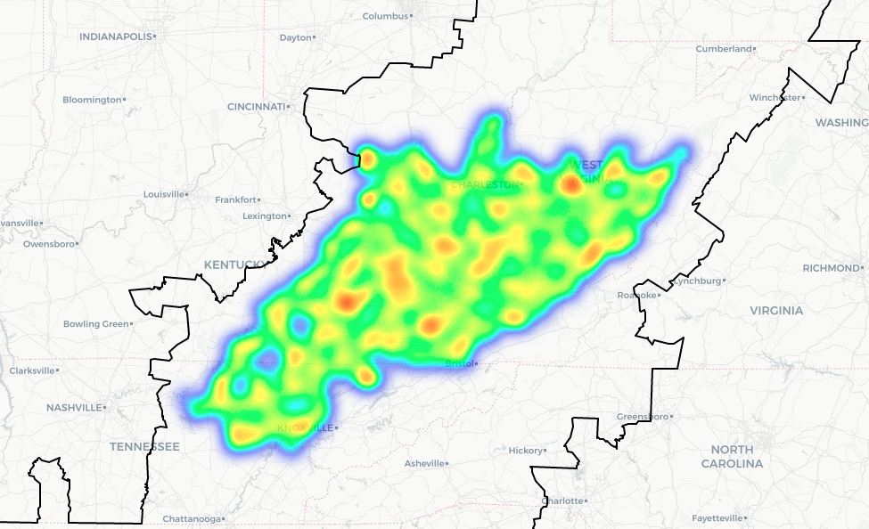

*Figure 24 – 2020 Central Appalachian Mine Heat Map*

There are clear clusters of mines shown in Figure 24 in several West Virginia, Kentucky, and Tennessee towns responsible for most of the coal production in Appalachia. These 238 counties are charted with broadband usage in Figure 25, which does not reveal a clear pattern with mine count and broadband access. It does, however, show that counties with more than 10 mines are almost all distressed or at-risk.

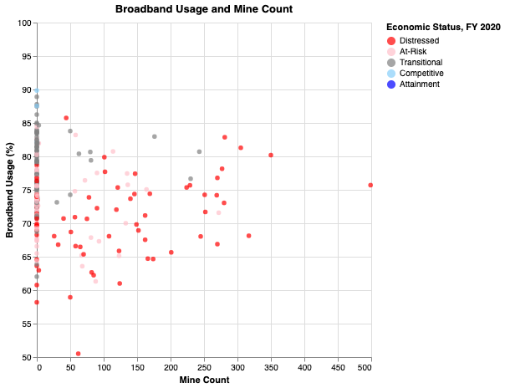

*Figure 25 – Mine Count and Internet Usage*

**Methods**

Considering the many counties in need of support, a ranking system that indicates which parts of Appalachia have the highest need for federal resources derived from demographics, education, and economic status, is needed. Once the data is collected, the creation of this ranking system is not a strict science and requires many decisions with regards to what is included and how each element is weighted. This report presents a single solution of proposed priorities for what could be most impactful economically; however, a government agency or private broadband company may have entirely different priorities.

After identifying the two main needs associated with broadband – infrastructure and subscription subsidies – two indexes that address these needs were developed.

*Broadband Infrastructure Index*

The Broadband Infrastructure Index (BII) considers which counties have the greatest need for, and will be most impacted by, broadband infrastructure. This index includes broadband, economic, demographic, and education values, which have been split into percentiles to maintain a range from 0 to 100 then plugged into the following formula:

BII = ( (2 * (100 – *“Broadband Access Percentile”*)) +

(1.5 * (100 – “*Broadband Usage Percentile”*)) +

(0.5 * *“Lowest Broadband Price Percentile”*) +

(1.25 * *“2020 Economic Index Percentile”*) +

(1.25 * “*5-year Economic Index Percentile*”) +

(0.5 * *“Mine Category*”) +

(1 * “*Young Working Age Percentile*”) +

(1 * (100 – “*Population Density Percentile*”) +

(0.5 * (100 – “*Enrollment Percentile*”)) +

(0.5 * “*Less than High School Percentile*”) +

(0.25 * “*At Least High School Percentile*”) +

(0.25 * (100 – “*At Least Bachelors Percentile*”)) +

)

To determine where broadband infrastructure should be built, the most important piece is current access, which is why this has the highest weight of 2 in the formula. These values are subtracted from 100 since the lowest percentage of access is desired (the larger the BII, the larger the potential impact). Next, the usage is included since the use of broadband is low in some regions where there is limited and expensive access. With more broadband infrastructure the cost will likely decrease, making it more affordable to residents. Usage is less important than access, so the weight is only 1.5, but it is similarly subtracted from 100 since the lowest percentage of usage is desired. The average lowest price is also taken into consideration for the same reason – regions where broadband is too expensive need new infrastructure to reduce the price – but this value has a much smaller weight of just 0.5.

The economic values included are the 2020 index, the 5-year average index, and the existence of mines in the county. The most current index value is important, with a weight of 1.25, but alone cannot accurately represent the county’s status. For that reason, a 5-year average is included with the same weight: 1.25. Finally, since coal mining is leaving such an impact on the economy of many Appalachian counties, a simple mine category is included to indicate if the county will likely lose industry and jobs in the near future. There are three categories, 0 for no mines in the county, 50 for less than 100 mines, or 100 for more than 100 mines. While this is relevant for parts of Appalachia, it does not apply to the entire region, so this value is given a small weight of just 0.5.

Next, demographic values focused on age of residents and population density are included. Since workers from 16 to 44 years old are likely to be most impacted by industry changes and open to higher education or workforce retraining, this age group is used instead of traditional working age (18-64). Age is relatively important, so it is assigned a weight of 1. Population density is an indication of how rural and unlikely a community is to have complete broadband coverage. This is also assigned a weight of 1.

Finally, the education access and achievement values have small weights to suggest where broadband could provide communities with educational resources or blue-collar jobs. Counties with the least education access have the most to gain with broadband because it provides the community with the opportunity to participate in online school. This is measured by enrollment per capita and assigned a weight of 0.5. Since college educated individuals have the most job opportunity, broadband will likely have a greater influence on counties with large groups that do not have a college degree. With that in mind, the percentage of residents without a high school diploma is given a weight of 0.5 and the percentage of residents with just a high school diploma is given a slightly smaller weight of 0.25. Lastly, the percentage of residents without a college degree (100 – the percent who have a degree) is given a weight of 0.25.

These weighted percentiles are totaled for each county to form the Broadband Infrastructure Index displayed in Figure 26 of the results section.

*Broadband Subsidy Index*

Although the BII will indicate which counties need physical construction of broadband infrastructure, some counties have access to broadband already, but it is simply too expensive. The FCC’s Lifeline program is designed to provide some subsidies to residents to make broadband more affordable, but the program falls short, leaving many Americans unable to connect. The Digital Equity Act within the IIJA may bridge some of this affordability gap, and the Broadband Subsidy Index (BSI) develops a prioritization system for the distribution of this support.

Compared with the Broadband Infrastructure Index, an index designed to identify the areas with the highest need for subsidy is relatively simple. The BSI uses just access, usage, and cost of broadband, along with the most recent economic index in the following formula:

BSI = ( (2 * (*“Broadband Access Percentile”*)) +

(1.5 * (100 – “*Broadband Usage Percentile”*)) +

(0.5 * *“Lowest Broadband Price Percentile”*) +

(1 * *“2020 Economic Index Percentile”*) +

)

The weights are assigned by importance – access is the most important and has a weight of 2, usage is second with 1.5, economic status is third with 1, and current price is just 0.5. While the BII targets counties without access to broadband, the BSI focuses on counties with access, therefore the value is not subtracted from 100 for this index. Alternatively, low broadband usage is targeted in both indexes, so it is once again subtracted from 100. The price is included in BSI also to target counties where broadband is abnormally expensive. While expensive subscription fees might require more subsidies, a poor county with an average subscription fee might still be out of reach for some residents making price not as important as economic status. Finally, a current economic status is necessary since a community’s subsidy needs may change more frequently than their infrastructure needs.

It is important to note that once the infrastructure is constructed in regions currently without broadband, some of those counties will likely need subsidies as well. However, without knowing exactly where broadband will be introduced, this is hard to predict. With that in mind, running this index equation again, once the construction is planned, could ensure that all constructed infrastructure is truly accessible to residents.

**Results**

Using the formula described in the methods section, BII and BSI were calculated for each county and are displayed in Figures 26 and 27.

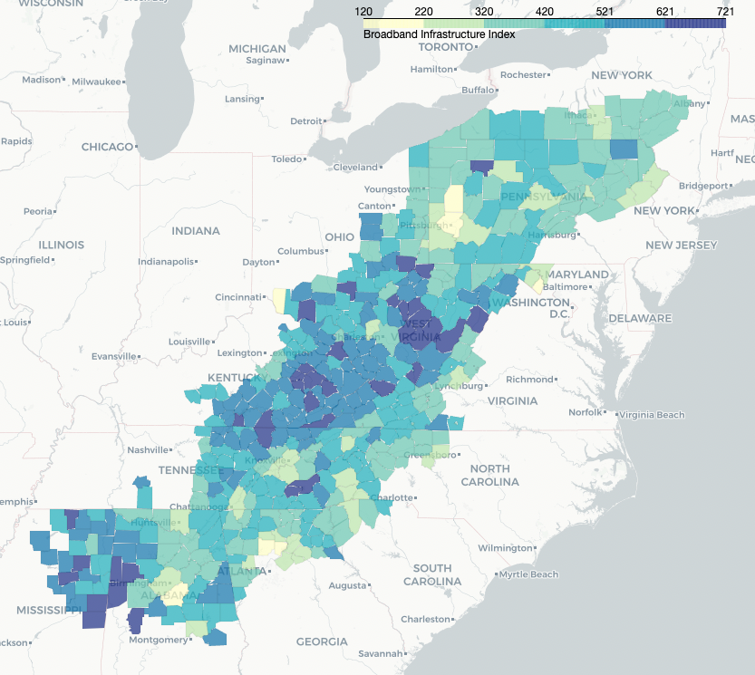

*Figure 26 – Broadband Infrastructure Index*

The Broadband Infrastructure Index is, unsurprisingly, similar to the economic index maps displayed in Figures 5 and 14. Kentucky, West Virginia, and Mississippi have the counties with the highest values, while counties in New York, Pennsylvania, Maryland, and Georgia are relatively low. Counties nearest urban areas like Pittsburgh, State College, Knoxville, and Atlanta have far lower BII values than their rural counterparts, which lack education access, are struggling economically, and often have coal mines.

This map contrasts with the Broadband Subsidy Index shown in Figure 27. In this case, most of the counties with high BSI are clustered in Kentucky. This is similar, by design, to the inverse of the usage map in Figure 10. The formula identifies the counties with high access and low usage, which is mostly in the poorest part of Appalachia – Eastern Kentucky.

The difference between the two maps shows the different needs of the region. While West Virginia counties need and appear to gain the most from broadband infrastructure, Kentucky on the other hand largely has the infrastructure but cannot afford to use it.

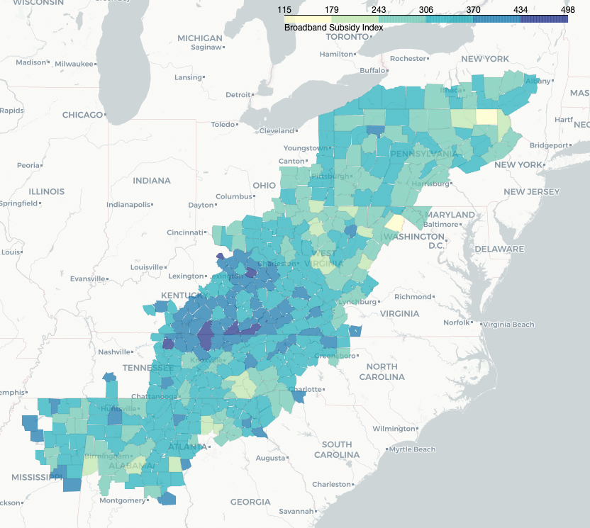

*Figure 27 – Broadband Subsidy Index*

The values are ordered and the top counties of each index are listed in Figure 28. BII ranged of 120 to 721, while BSI ranged from 115 to 498.

|  |  |  |
| --- | --- | --- |
| **Top BII Counties** |  | **Top BSI Counties** |
| 1) Clay County, West Virginia |  | 1) Robertson County, Kentucky |
| 2) Noxubee County, Mississippi |  | 2) Lee County, Virginia |
| 3) Hale County, Alabama |  | 3) McCreary County, Kentucky |
| 4) Webster County, West Virginia |  | 4) Norton City County, Virginia |
| 5) Pickens County, Alabama |  | 5) Bell County, Kentucky |

*Figure 28 – Tables of Highest BII and BSI Counties*

The county with the highest BII, Clay County, West Virginia, is small with a population under 9,000 residents, only 40% of which have access to terrestrial broadband. 31% of those residents are between 16 and 44 and 50% make less than $35,000 annually contributing to the county’s distressed economic designation every year since 2007. There are 0 higher education institutions in Clay County, but 102 coal mines.

The county with the highest BSI, Robertson County, Kentucky, is even smaller than Clay County with only 2,200 residents. 100% of the residents have access to terrestrial broadband, but only 60% use it in any form - terrestrial, satellite, or cellular. This is possibly due to expensive monthly broadband subscriptions at $203. This is not affordable for the county, which has had the distressed or at-risk economic designation since it was added to the ARC boundaries in 2009. There are no coal mines nor high education institutions in Robertson County.

Both top counties are within the Central Appalachian subregion and clearly need federal support in their own ways. Interestingly, Clay County has the highest BII value at 721, but a BSI value in the bottom 30% at 226. Robertson County is highest in BSI at 498, and relatively high in BII as well with a value of 597. This indicates that Robertson needs both infrastructure and subsidy assistance.

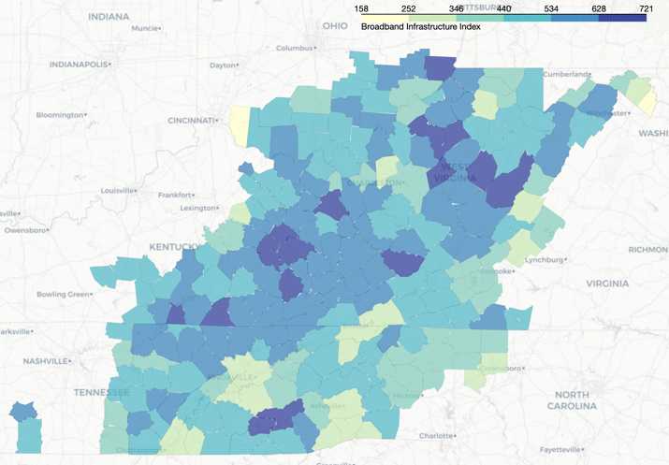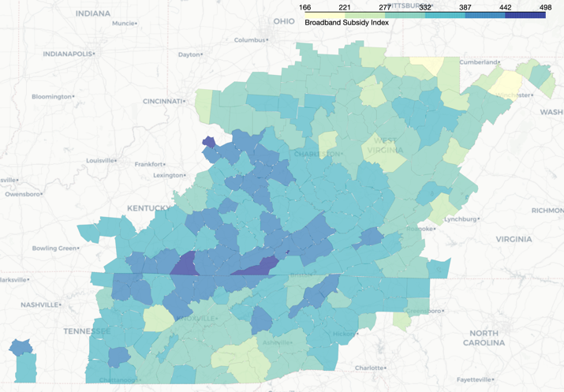

*Figure 29 – Central Appalachia BII (left) and BSI (right)*

Figure 29 looks specifically at the North Central, Central, and South Central Appalachian subregions, where counties are largely in distress or at-risk in part due to the decline of coal mining. These maps side-by-side highlight the unique needs of each county. Although the subregions share industry and demographics, the counties are certainly not homogenous. Several counties have low BII, but high BSI and vice-versa.

**Limitations**

Although this investigation attempts to consider many contributing factors to broadband need and impact, there are several limitations to the study. Firstly, the data comes from a variety of sources, which collect relevant information differently. Some, like the American Community Survey and Broadband Now, rely on a sample of surveys and careful modeling to fill in gaps. Surveys are only as accurate as the people filling them out – some residents might not know the different types of broadband and self-reporting could be inaccurate. Additionally, these sources might not entirely agree on definitions and their data collection efforts might include some bias, which could conflict from source to source.

Secondly, the county scale used in this study is not a homogenous sample. Counties are large and can contain pockets of people and conditions that are entirely different. A further investigation on a small scale, perhaps at the census tract level, might increase accuracy and the specificity of resource allocations. Counties were used given the scope of the investigation; Appalachia is a large region, but once the general trends in needs and impact are established a closer look into these areas on the tract level may be more fruitful.

Additionally, education access is a challenging topic, which enrollment per capita does not entirely represent. Higher education institutions vary in acceptance rates and tuition costs making them not uniformly accessible to residents. Also, the list used from IPEDS includes all institutions regardless of level and specificity. A beauty and hair salon trade school may not be as relevant to broadband infrastructure as a school that specializes in tech or telecommunications. Refinement of the list and access metric could make for a clearer picture into education trends of the region.

Unfortunately, the cost of implementation was outside the scope of this study but could be relevant to a resource allocation project such as this. To completely model the cost of implementation, environmental factors should be calculated. For example, connecting a region over a flat distance is far less expensive than over a mountain range or around a body of water.

There is an argument to be made that the cost of implementation should not matter since the ultimate goal is complete coverage. However, the order in which broadband infrastructure is constructed should be intentional – expanding and connecting existing networks is far less expensive that building new infrastructure entirely. Therefore, disconnected counties that boarder counties with established infrastructure would be the least expensive areas to start with and will in turn make the more remote regions less expensive by gradually reducing their distance to existing infrastructure. This level of detail would be a useful next step in this investigation but is beyond the scope of this report.

Considering the limited scope of the project, the resulting indexes are a single proposal, but, as stated in the methods section, any government entity or private company likely have other priorities that may change the index and rankings of counties.

**Conclusion**

While the US economy phases out coal, the digital economy is here to stay. Without reliable, high-speed internet, rural communities will fall further behind connected suburban and urban areas in economic health, education achievement, and healthcare access. The unique landscape of Appalachia makes it tremendously difficult to reach remote, rural communities with terrestrial broadband, leaving residents without a connection or stuck with expensive and unreliable options. Since private companies are unlikely to build the network for relatively small populations across mountains, the responsibility falls on the government to make sure the internet is accessible for all.

A set of indexes, derived from public data, creates a prioritization approach to the distribution of federal funds through the IIJA. This future connection could be the jumpstart Appalachia needs to rebound the local economies that are plagued by industry collapse over the last several decades. While some say the region can reinvent itself through workforce retraining and become the next tech hub of America, an improved broadband is a necessary ingredient to recovery even if miners do not become coders. The infrastructure index (left) and subsidy index (right) displayed in Figure 30, consider the unique situations of each county.

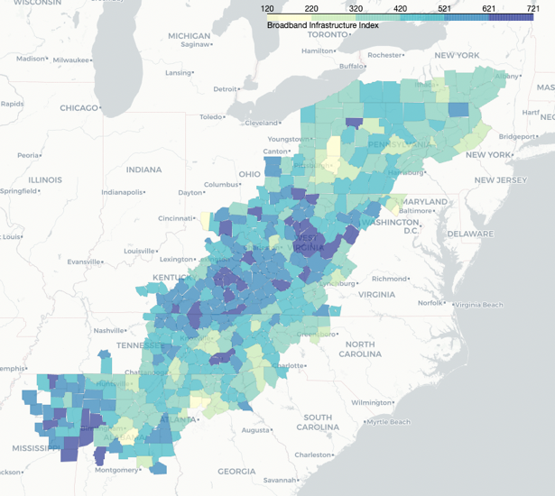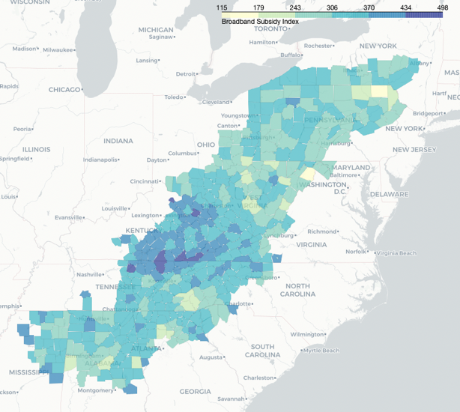

*Figure 30 – Broadband Infrastructure Index (left) and Broadband Subsidy Index (right)*

To study this topic further, a smaller scale like the census tract level would provide a more granular look into the access and use of broadband. Research into internet subsidy legislation and environmental modeling for network construction would inform this resource allocation beyond the scope of this report, but these indexes consider many trends in the region and produce a reasonable approach to connect Appalachia.

It is important to note that not everyone wants broadband. Some Americans will opt out of connecting to the internet and have every right to do so. But all Americans should have the chance to make that decision with affordable, reliable broadband service regardless of where they live.

**Instructions for Use of Customizable Index Workbook**

As stated in the Methods section, this report produces a single suggestion for prioritization. Another set of weights or entirely different data may be more relevant to a government agency or private business. With that in mind, a jupyter notebook is provided in the [GitHub](https://github.com/CPLN-680-Spring-2022/Aiken_Ben_AppalachiaBroadband) titled “Customizable Index Workbook”, which can be used to calculate a new set of indexes and prioritization order.

The workbook provides step-by-step instructions to download the data, create a new index (or set of indexes), map it, and save the results. When paired with this report, specifically the methods section, the notebook should allow anyone with basic python skills to create their own indexes to inform resource allocations.

1. **Works Cited**

   1Cover image taken by Mike Belleme for The New York Times: <https://www.nytimes.com/2021/08/02/us/broadband-infrastructure.html>
2. “Digging Deeper into the 2021 Infrastructure Bill: Broadband | BidNet Direct.” www.bidnetdirect.com. <https://www.bidnetdirect.com/resources/articles/digging-deeper-Into-the-2021-infrastructure-bill-broadband>.
3. Maloney, Michael. 2015. “What Is Appalachian Culture? - Urban Appalachian Community Coalition.” Urban Appalachian Community Coalition. July 24, 2015. <https://uacvoice.org/2015/07/what-is-appalachian-culture/>.
4. Appalachian Regional Commission. “About the Appalachian Region.” <https://www.arc.gov/about-the-appalachian-region/>.
5. Bowen, Eric, John Deskins, and Brian Lego. 2018. “An Overview of the Coal Economy in Appalachia.” *Appalachian Regional Commission*. <https://www.arc.gov/wp-content/uploads/2018/01/CIE1-OverviewofCoalEconomyinAppalachia-2.pdf>.
6. “The Data Is Clear: Coal Remains Vital to West Virginia and the U.S., for Now.” WV News. July 1, 2021. <https://www.wvnews.com/theet/opinion/editorials/the-data-is-clear-coal-remains-vital-to-west-virginia-and-the-u-s-for/article_e40e973f-548d-5de0-ba1d-f0b86c358ae0.html>.
7. Data collected from the Bureau of Economic Analysis within the US Department of Commerce found at: <https://apps.bea.gov/iTable/iTable.cfm?reqid=70&step=1&isuri=1&acrdn=1#reqid=70&step=1&isuri=1&acrdn=1>
8. Production numbers were found in the US Energy Information Administration’s Annual Energy Review (<https://www.eia.gov/totalenergy/data/annual/pdf/sec7_7.pdf>). Employment numbers are from the US Bureau of Labor Statistics, All Employees, Coal Mining [CES1021210001], retrieved from FRED, Federal Reserve Bank of St. Louis (<https://fred.stlouisfed.org/series/CES1021210001>).
9. Tate, Curtis. 2021. “Kentucky Coal Production, Employment Decline Slows in 1st Quarter.” Ohio Valley ReSource. May 18, 2021. <https://ohiovalleyresource.org/2021/05/18/kentucky-coal-production-employment-decline-slows-in-1st-quarter/>.
10. Energywire. 2020. “Thousands of Coal Workers Lost Jobs. Where Will They Go?” Energy News Network. June 25, 2020. <https://energynews.us/2020/06/25/thousands-of-coal-workers-lost-jobs-where-will-they-go/>.
11. FCC. 2020. “2020 Broadband Deployment Report.” Federal Communications Commission. <https://docs.fcc.gov/public/attachments/FCC-20-50A1.pdf>.
12. Busby, John, and Julia Tanberk. 2020. “FCC Underestimates Americans Unserved by Broadband Internet by 50%.” BroadbandNow. February 3, 2020. <https://broadbandnow.com/research/fcc-underestimates-unserved-by-50-percent>.
13. Smith, Brad. 2018. “The Rural Broadband Divide: An Urgent National Problem That We Can Solve.” Microsoft on the Issues. December 4, 2018. <https://blogs.microsoft.com/on-the-issues/2018/12/03/the-rural-broadband-divide-an-urgent-national-problem-that-we-can-solve/>.
14. Bureau, US Census. 2021. “Working from Home during the Pandemic.” The United States Census Bureau. March 31, 2021. <https://www.census.gov/library/stories/2021/03/working-from-home-during-the-pandemic.html>.
15. Education Week. 2020. “Map: Coronavirus and School Closures in 2019-2020.” March 7, 2020. <https://www.edweek.org/leadership/map-coronavirus-and-school-closures-in-2019-2020/2020/03>.
16. Johnson, Angela, Megan Kuhfeld, and James Soland. 2021. “The Forgotten 20%: Achievement and Growth in Rural Schools across the Nation.” *AERA Open* 7 (January). <https://doi.org/10.1177/23328584211052046>.
17. Tribune, Emily Pyrek La Crosse. 2020. “Number of Telehealth Visits Rapidly Rising at Gundersen, Mayo during COVID-19.” La Crosse Tribune. April 6, 2020. <https://lacrossetribune.com/news/local/number-of-telehealth-visits-rapidly-rising-at-gundersen-mayo-during-covid-19/article_4886203e-1527-5558-a877-d7688be0d995.html>.
18. ITU. 2012. “Impact of Broadband on the Economy Broadband Series Regulatory & Market Environment.” <https://www.itu.int/ITU-D/treg/broadband/ITU-BB-Reports_Impact-of-Broadband-on-the-Economy.pdf>.
19. Litan, Robert W. Crandall, William Lehr, and Robert E. 2007. “The Effects of Broadband Deployment on Output and Employment: A Cross-Sectional Analysis of U.S. Data.” Brookings. June 1, 2007. <https://www.brookings.edu/research/the-effects-of-broadband-deployment-on-output-and-employment-a-cross-sectional-analysis-of-u-s-data/>.
20. Raul, L, and Katz. 2009. “ESTIMATING BROADBAND DEMAND and ITS ECONOMIC IMPACT in LATIN AMERICA.” <http://www.acorn-redecom.org/papers/acornredecom2009katz.pdf>.
21. FCC. 2011. “Getting Broadband Q&A.” Federal Communications Commission. May 10, 2011. <https://www.fcc.gov/consumers/guides/getting-broadband-qa>.
22. Broadband Access data explained by BroadbandNow here: <https://broadbandnow.com/research/data> Data is found on GitHub here: <https://github.com/BroadbandNow/Open-Data>
23. Khanna, Ro. 2022. “What Silicon Valley Can Learn from ‘Silicon Holler.’” The Atlantic. February 2, 2022. <https://www.theatlantic.com/ideas/archive/2022/02/ro-khanna-digital-revolution-silicon-valley-jobs/621421/>.
24. “About Tech Valley.” Tech Valley. <http://www.techvalley.org/Pages/Live/About%20Tech%20Valley.html>.
25. Feder, Barnaby J. 1988. “I.B.M. Set to Close 5 Factories.” *The New York Times*, June 30, 1988, sec. Business. <https://www.nytimes.com/1988/06/30/business/ibm-set-to-close-5-factories.html>.
26. Spector, Joseph. 2015. “IBM Plants Sale to GlobalFoundries Expected to Close July 1.” Press & Sun-Bulletin. June 19, 2015. <https://www.pressconnects.com/story/news/local/new-york/2015/06/19/ibm-plans-sale/28990619/>.
27. Rulison, Larry. 2015. “Made in Albany: IBM Reveals Breakthrough Chip Made at SUNY Poly.” Times Union. July 10, 2015. <https://www.timesunion.com/news/article/Made-in-Albany-IBM-reveals-breakthrough-chip-6376816.php>.
28. Global Foundries. 2021. “GLOBALFOUNDRIES Moves Corporate Headquarters to Its Most Advanced Semiconductor Manufacturing Facility in New York | GlobalFoundries.” Global Foundries. April 26, 2021. <https://gf.com/globalfoundries-moves-corporate-headquarters-its-most-advanced-semiconductor/>.
29. Bobrowsky, Meghan. 2022. “Intel to Invest at Least $20 Billion in Ohio Chip-Making Facility.” *Wall Street Journal*, January 21, 2022, sec. Tech. <https://www.wsj.com/articles/intel-to-invest-at-least-20-billion-in-ohio-chip-making-facility-11642750760>.
30. Leswing, Kif. 2021. “Intel Is Spending $20 Billion to Build Two New Chip Plants in Arizona.” CNBC. March 23, 2021. <https://www.cnbc.com/2021/03/23/intel-is-spending-20-billion-to-build-two-new-chip-plants-in-arizona.html>.
31. Robertson, Campbell. 2019. “They Were Promised Coding Jobs in Appalachia. Now They Say It Was a Fraud.” *The New York Times*, May 12, 2019, sec. U.S. <https://www.nytimes.com/2019/05/12/us/mined-minds-west-virginia-coding.html>.
32. Jones, Sarah. 2019. “Please Stop Telling Miners to Learn to Code.” Intelligencer. New York Magazine. December 31, 2019. <https://nymag.com/intelligencer/2019/12/coding-jobs-wont-save-coal-country.html>.
33. Selingo, Jeffrey. 2018. “The False Promises of Worker Retraining.” The Atlantic. January 8, 2018. <https://www.theatlantic.com/education/archive/2018/01/the-false-promises-of-worker-retraining/549398/>.
34. Kentucky, Cassady Rosenblum in Pikeville. 2017. “Hillbillies Who Code: The Former Miners out to Put Kentucky on the Tech Map.” The Guardian. April 21, 2017. <https://www.theguardian.com/us-news/2017/apr/21/tech-industry-coding-kentucky-hillbillies>.
35. “About Us.” Bit Source, LLC. <https://bitsourceky.com/about/>.
36. “What Is Silicon Hollar?” Silicon Hollar. <https://www.siliconhollar.org/what-is-siliconhollar>.
37. Godfrey, Elaine. 2017. “Trump’s Proposal to Scrap the Agency Devoted to Developing Appalachia.” The Atlantic. March 16, 2017. <https://www.theatlantic.com/politics/archive/2017/03/why-the-appalachian-regional-commission-matters/519876/>.
38. Appalachian Regional Commission. “About the Appalachian Region.” <https://www.arc.gov/about-the-appalachian-region/>.
39. Keller & Heckman LLC. 2022. “The Digital Equity Act.” The National Law Review. January 20, 2022. <https://www.natlawreview.com/article/digital-equity-act>.
40. Wheeler, Tom. 2020. “5 Steps to Get the Internet to All Americans.” Brookings. May 27, 2020. <https://www.brookings.edu/research/5-steps-to-get-the-internet-to-all-americans/>.
41. Mine data explained found here: <https://skytruth.org/mtr-data-files/>
42. Pericak, Andrew A., Christian J. Thomas, David A. Kroodsma, Matthew F. Wasson, Matthew R. V. Ross, Nicholas E. Clinton, David J. Campagna, Yolandita Franklin, Emily S. Bernhardt, and John F. Amos. 2018. “Mapping the Yearly Extent of Surface Coal Mining in Central Appalachia Using Landsat and Google Earth Engine.” Edited by Juan A. Añel. *PLOS ONE* 13 (7): e0197758. <https://doi.org/10.1371/journal.pone.0197758>.
43. Education data found here: <https://nces.ed.gov/ipeds/datacenter/DataFiles.aspx?gotoReportId=7&fromIpeds=true&>
44. Appalachian Regional Commission. “Classifying Economic Distress in Appalachian Counties.” <https://www.arc.gov/classifying-economic-distress-in-appalachian-counties/>.
45. Alwin, Ramsey, and Lona Choi-Allum. 2020. “Career Journeys of Adults 35 and Older.” AARP. April 2020. <https://www.aarp.org/research/topics/economics/info-2019/adults-career-journeys.html>.
46. “Coal Miner Demographics and Statistics [2021]: Number of Coal Miners in the US.” 2021. Zippia. January 29, 2021. <https://www.zippia.com/coal-miner-jobs/demographics/>.
47. Vilorio, Dennis. 2016. “Education Matters : Career Outlook: U.S. Bureau of Labor Statistics.” US Bureau of Labor Statistics. March 29, 2016. <https://www.bls.gov/careeroutlook/2016/data-on-display/education-matters.htm>.